Project: Lead Intent & Priority Scorer

1. Your Project: Lead Intent & Priority Scorer
Project Title: AI-Based Lead Intent & Priority Scorer
Domain: Artificial Intelligence, Machine Learning, and Sales Analytics
Objective: To predict which prospective students are most likely to take admission and help admission counsellors prioritize their follow-up calls.
Your project plan describes an ML system that assigns leads a conversion score from 0–100 and classifies them according to their likelihood of converting into paid enrolments.
2. What is the actual problem statement?
Imagine MIT ADT University receives 1,000 enquiries from students interested in admission.
The admission counsellors have limited time, and they cannot call everyone immediately.
Some students are highly interested, some are still exploring their options, and others may never take admission.
Currently, counsellors might call students in the order their enquiries arrive or rely on their personal judgement.
The problem is that counsellors don't have a reliable, data-driven way to identify which leads should receive attention first.
Your project aims to solve this problem using Machine Learning.
Formal problem statement
Educational institutions receive a large volume of admission enquiries through websites, campaigns, and other channels. However, identifying prospective students who are most likely to convert into enrolled students remains challenging. Traditional lead management approaches often rely on manual assessment and counsellor intuition, resulting in inefficient follow-ups and missed admission opportunities.
The proposed Lead Intent & Priority Scorer uses Machine Learning techniques to analyse historical lead data, predict the likelihood of conversion, assign a lead priority score, and classify prospective students into High, Medium, and Low priority categories. An interactive dashboard helps admission counsellors make data-driven decisions and allocate their time more effectively.
In simple words: Predict who is most likely to take admission, assign them a score, and help counsellors decide whom to contact first.

3. How will your project work?
Here's the workflow I recommend for your project.
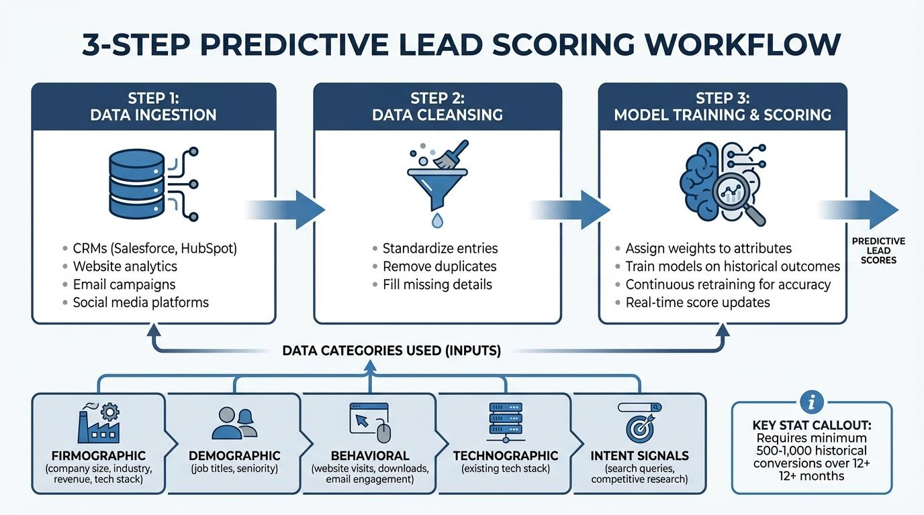
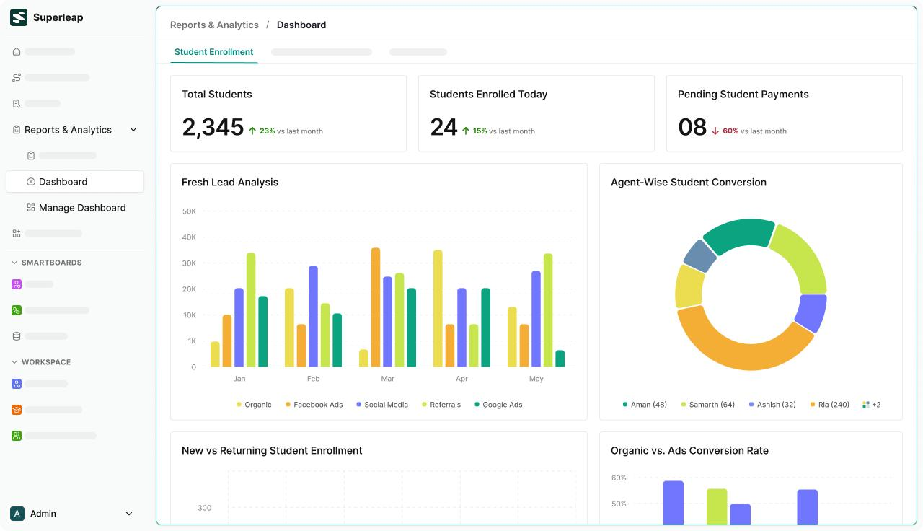
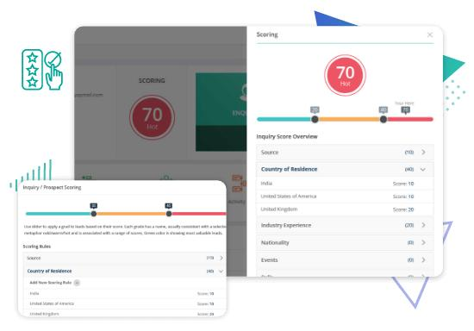
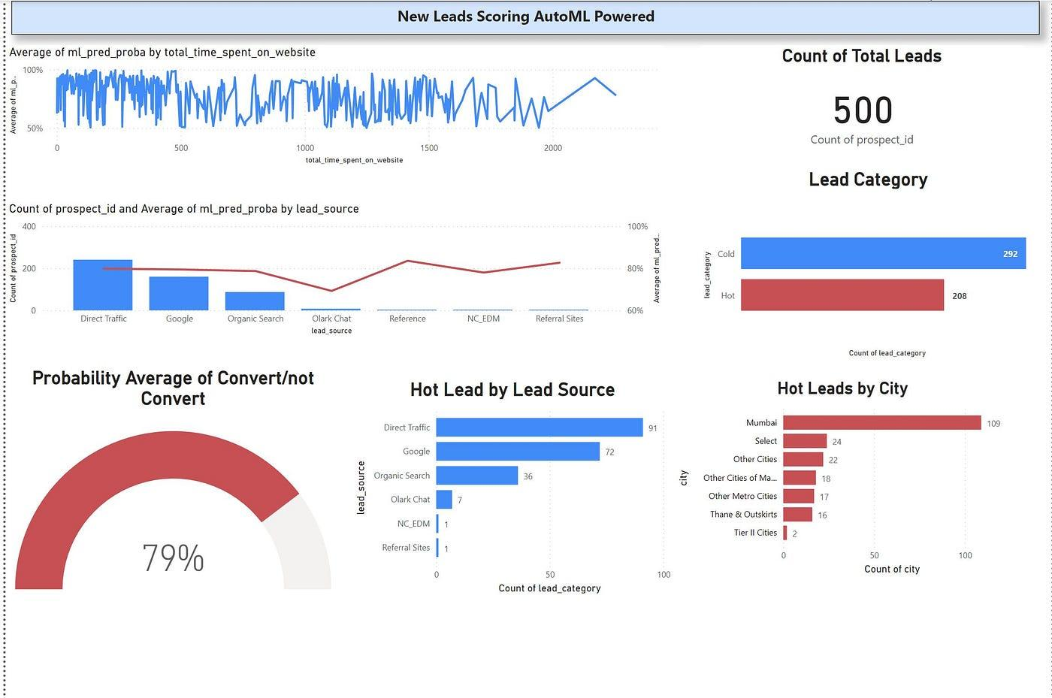
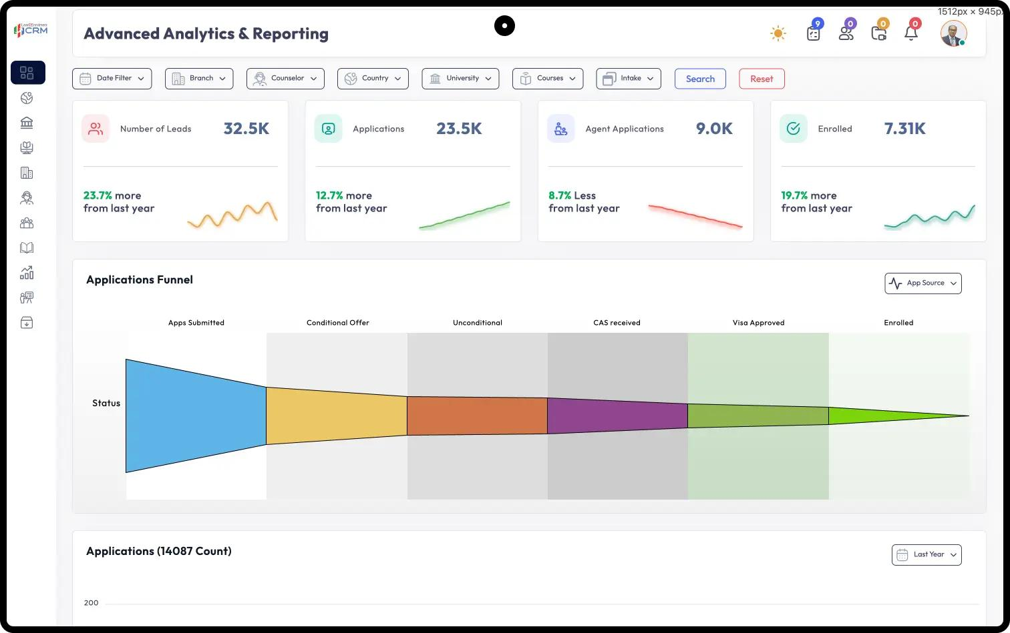
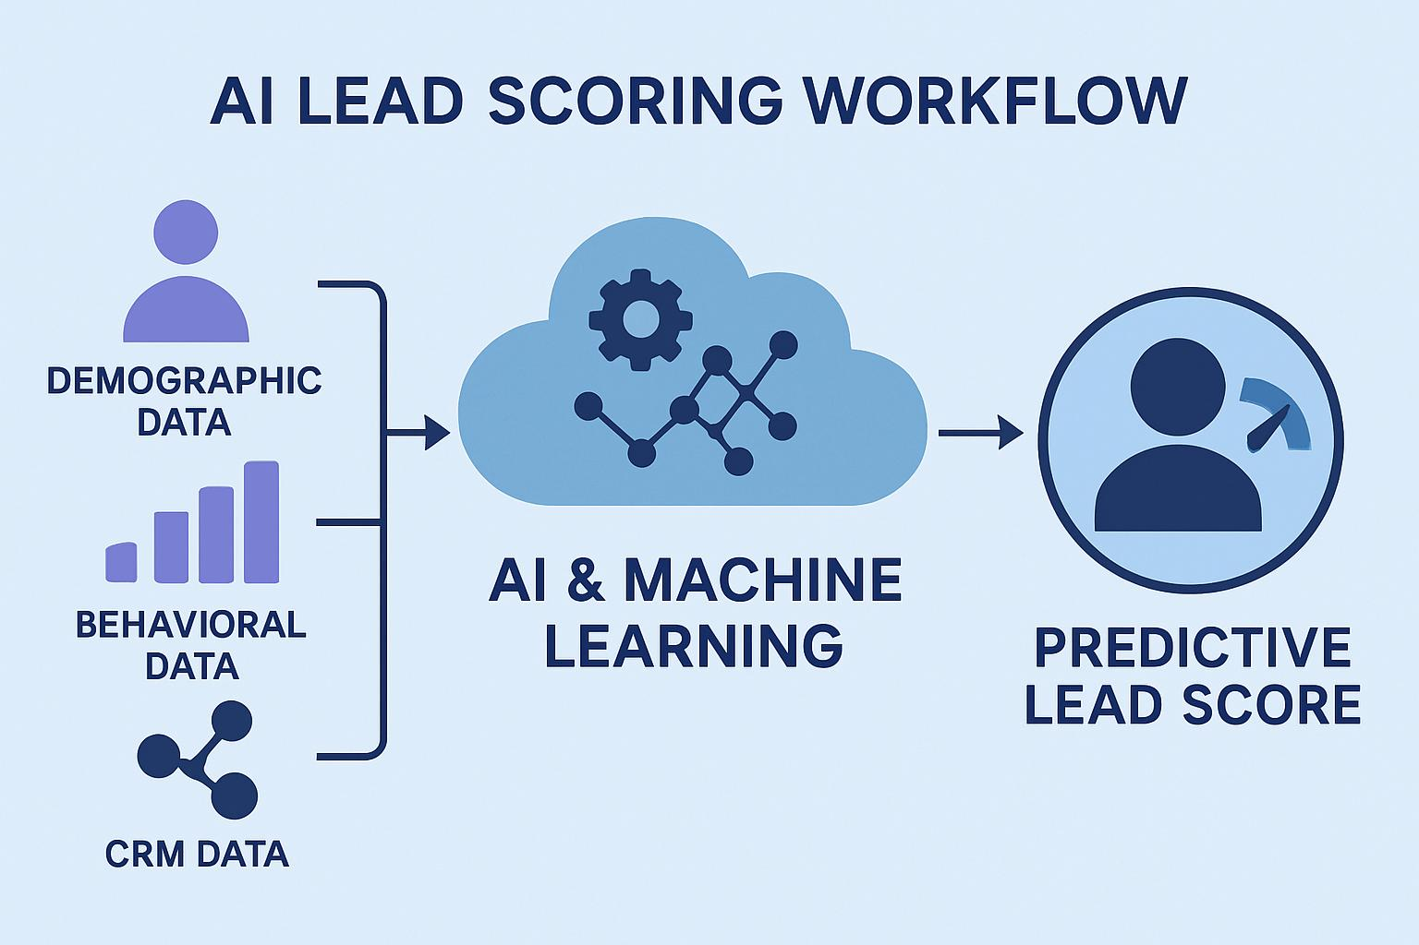
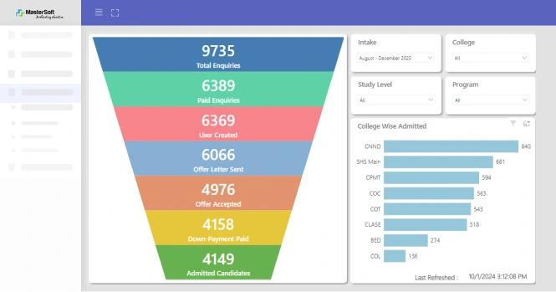
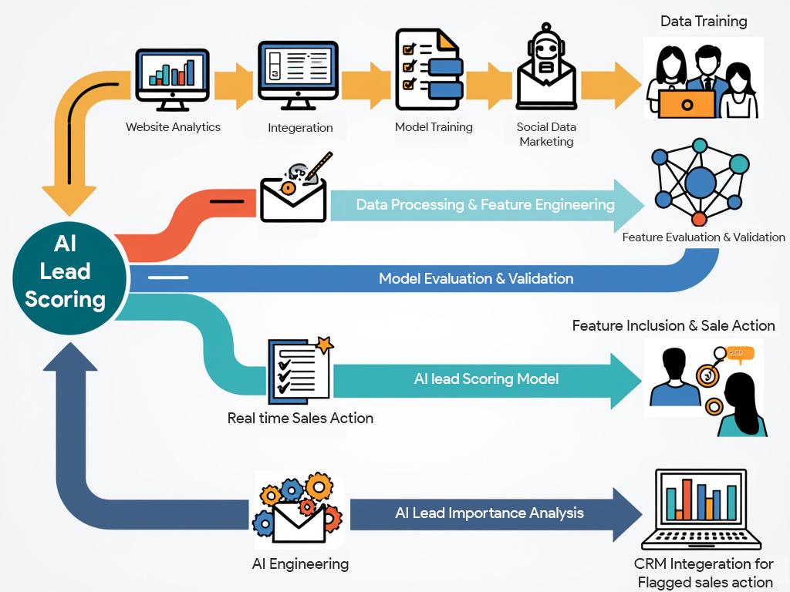
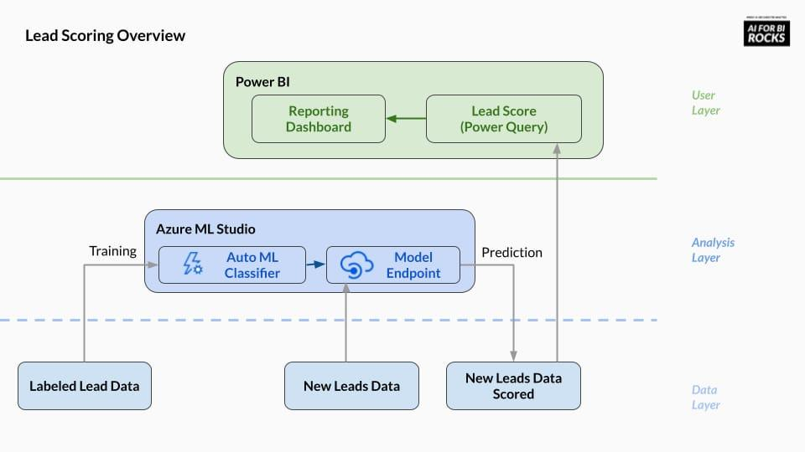
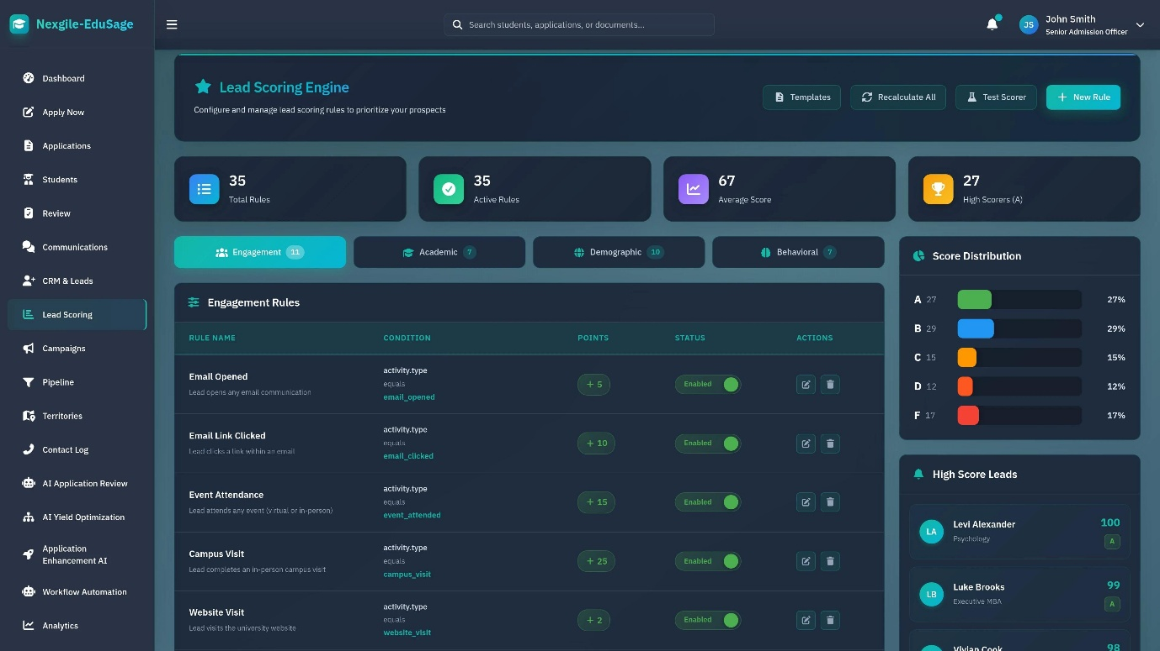
Step 1: Collect lead data
We'll use a historical lead dataset containing information such as:
- Lead source
- Time spent on the website
- Number of website visits
- Last recorded activity
- Occupation
- City
- Previous interactions
- Whether the lead converted
Your uploaded plan identifies the X Education Lead Scoring dataset, with approximately 9,240 records and 37 columns.
Step 2: Data preprocessing
We'll prepare the data by:
- Handling missing values.
- Removing duplicate records where appropriate.
- Correcting inconsistent categories.
- Encoding categorical variables.
- Checking for data leakage.
Step 3: Exploratory Data Analysis (EDA)
We'll investigate questions such as:
- Which lead sources generate the most conversions?
- Do students who spend more time on the website convert more often?
- Which activities are associated with higher conversion rates?
- What percentage of leads actually convert?
We'll use charts and statistics to identify useful patterns.
Step 4: Train Machine Learning models
We'll compare multiple classification algorithms.
Model | Purpose
Logistic Regression | Establish a baseline model
Random Forest | Identify patterns and interactions in lead data
XGBoost | Evaluate a gradient-boosting approach
We'll evaluate the models using precision, recall, F1-score, ROC-AUC, and other appropriate metrics.
We won't automatically select the model with the highest accuracy because identifying likely converters correctly is more important than accuracy alone.
Step 5: Generate a lead score
Suppose the model produces the following illustrative predictions:
Student | Predicted conversion probability | Priority
Student A | 91% | High
Student B | 67% | Medium
Student C | 24% | Low
These values are examples, not actual model results.
The system will use the model's predicted probability to generate a score between 0 and 100.
We'll define suitable priority thresholds based on model performance and the institution's follow-up capacity.
Step 6: Explain the prediction using SHAP
This is where we can make your project more impressive.
Instead of simply displaying a score, the dashboard can explain which available features influenced the prediction.
For example:
Lead Score: 87/100 — High Priority
Potential contributing factors might include:
- High website engagement.
- Multiple website visits.
- A particular pattern of recorded interactions.
These explanations will be based on the actual trained model, rather than fabricated reasons.
Step 7: Build a Streamlit dashboard
The final application could include these pages:
Page | Features
Executive Dashboard | Total leads, conversion rate, high-priority leads
Lead Analytics | Conversion trends by source, city, and activity
Lead Scoring | Enter lead information and predict conversion probability
Priority Management | Sort and filter leads by predicted score
Model Performance | Compare models and evaluation metrics
Explainable AI | Display feature importance and individual prediction explanations
We can also add CSV uploads, allowing counsellors to score multiple leads at once.

4. What will make your project professional?
I don't recommend stopping at a basic model that predicts 0 or 1.
Let's build a complete, integrated application.
Recommended technology stack
Component | Technology
Programming | Python
Data manipulation | Pandas, NumPy
Data visualisation | Plotly, Matplotlib, Seaborn
Machine Learning | Scikit-learn, XGBoost
Explainable AI | SHAP
Database | SQLite
Dashboard | Streamlit
Development | Jupyter Notebook, VS Code
Version control | Git and GitHub
We'll use only the tools that add value to the final application.
Recommended project structure
lead-intent-priority-scorer/
│
├── data/
│ ├── raw/
│ └── processed/
│
├── notebooks/
│ ├── 01_data_understanding.ipynb
│ ├── 02_data_cleaning_eda.ipynb
│ ├── 03_feature_engineering.ipynb
│ └── 04_model_training_evaluation.ipynb
│
├── src/
│ ├── preprocessing.py
│ ├── feature_engineering.py
│ ├── train.py
│ ├── predict.py
│ └── explainability.py
│
├── models/
│ └── best_model.pkl
│
├── app/
│ ├── Home.py
│ └── pages/
│ ├── 1_Lead_Analytics.py
│ ├── 2_Lead_Scoring.py
│ ├── 3_Priority_Management.py
│ └── 4_Model_Insights.py
│
├── tests/
│
├── requirements.txt
├── README.md
└── .gitignore
This is a proposed structure. We can adjust it once we locate your previous work.

5. But first, can we recover your previous project?
Yes, let's try to find your existing work before rebuilding everything.
Since you've already made this project, we should avoid duplicating work unnecessarily.
You might have saved it in GitHub, Google Colab, Google Drive, or your computer.
Here is what I suggest.
Option A — Search GitHub
Open your GitHub account and search your repositories for names containing:
- Lead
- Scoring
- Priority
- Admission
- Intent
Option B — Search your computer
If you used VS Code, open the folder where you usually keep your projects and search for folders or files containing lead, scoring, or priority.
You can also search your computer for files named app.py, train.py, or notebooks related to this project.
Option C — Search Google Colab
Open Google Colab and check your recent notebooks and saved notebooks.
Option D — Check the uploaded project plan
Your Markdown file contains the project concept, dataset, team roles, timeline, and deliverables. It doesn't establish where the earlier code or deployed application is located.

6. Tell me just one thing so we can proceed
Where did you build this project previously?
Choose whichever option is closest:
1. GitHub + VS Code
2. Google Colab
3. Jupyter Notebook
4. Streamlit Cloud
5. I don't remember where I made it
6. I remember the project, but I can't find the code or repository.
If you choose option 5 or 6, that's completely fine. We'll start by locating your existing work. If we cannot recover it, I'll help you rebuild the entire project from the dataset to the deployed Streamlit dashboard, step by step, with working code and a professional GitHub repository.

